

The Pen

The Pen

INTRODUCTION

Peculiar Pen Facts

  - “pen” from the Latin penna/pinna ________________________________.

  - It’s a fact! The rise and spread of ________________________ increased the demand for permanent written religious documents.

  - The ___________________ was the principal writing implement for nearly _________________________!

  - The Parade of the Pens!

    - Quill pen - __________________________________
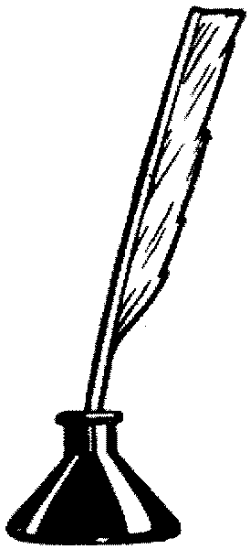
    - Fountain pen -___________________________________________________________________________________________________

    - Ball point pen - ______________________________________________________________________________________________________

    - Fiber tip pen - ____________________________________________________________________

  - There is no lead in a lead pencil! A pencil does not contain any lead, but ___________________________________________________________.

Pen Vs. Pencil

__________________________ __________________________
__________________________ __________________________
__________________________ __________________________
__________________________ __________________________
__________________________ __________________________
__________________________ __________________________
____________ __ __________________________
____________ __ __________________________
__________________________ __________________________
__________________________ __________________________
__________________________ __________________________
__________________________ __________________________

Are You Prepared for the Pen?

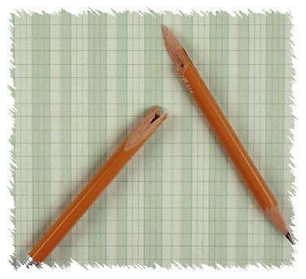
  - Do you enjoy writing?
_____________________________________________________________________________________________________________________________________________________________________________________________

  - Are you willing to do your best to make yourself prepared to work for the kingdom of God?
_____________________________________________________________________________________________________________________________________________________________________________________________

  - Write: a masterpiece of an essay.
_____________________________________________________________________________________________________________________________________________________________________________________________

The Preeminent Pen

  - Webster’s: ________________________________________________________________________________________________________________________

  - Places of Use
    - _________________________________________________
    - _________________________________________________
    - _________________________________________________
    - _________________________________________________
    - _________________________________________________
    - _________________________________________________

C. Scope of Influence
    - _________________________________________________
    - _________________________________________________
    - _________________________________________________
    - _________________________________________________
    - _________________________________________________

The Powerful Pen

  - Have you been influenced by something that you have read?
_______________________________________________________________

  - “The Pen of a Ready Writer” Psalm 45:1
_______________________________________________________________

  - Examples of Powerful & Influential pieces of literature.
    - _____________________________________
    - _____________________________________
    - _____________________________________
    - _____________________________________
    - _____________________________________
    - _____________________________________
    - _____________________________________
    - _____________________________________
    - _____________________________________
    - _____________________________________

  - ASSIGNMENT: ________________________________________________________________________________________________________________________________________________________________________________________________________________________________________________

The Perspicacious Pen

  - Webster’s: ____________________________________________________________________________________________________________________________________________________________________________________

  - Precision Expression – vocabulary; succinctness

  - Clear Expression – effectively communicating

The Personable Pen

  - Webster’s: pleasant or amiable in person; (amiable – generally agreeable)

  - Colorful Expression – How can your writing be ‘colorful’?
    - _________________________________________
    - _________________________________________
    - _________________________________________

  - Beautiful Expression
    - ___________________________
    - ___________________________
    - ___________________________

The Polished Pen

There are three simple steps to developing a “polished pen”:
    - ______________________
    - ______________________
    - ______________________

CONCLUSION

  - ________________________________________________________________________________________________________________________

  - ________________________________________________________________________________________________________________________

